Empathy Map Canvas

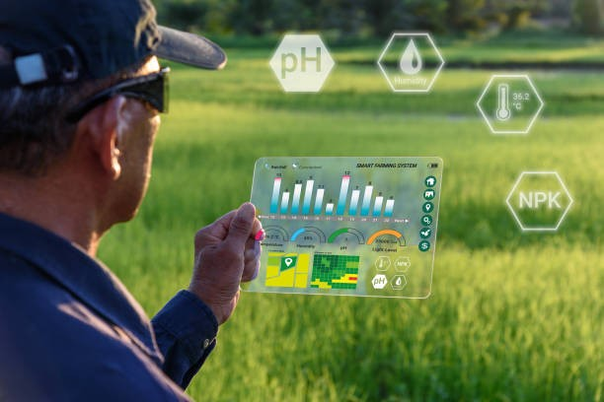

like humidity, temperature, soil moisture,

farm's data

Smart Farming

Gain insight and understanding on solving customer problems.

1

Build empathy and keep your focus on the user by putting yourself in their shoes.

it is difficult in real time

it take some time

more cofidence

excited for results

my team hardwork

Greenhouse automation.

...

Precision farming.

Mini robots

Poor Internet Connectivity in Farms

High Hardware Costs.

install required software

Crop Protection.

Soil Testing & its Quality.

Real-Time Crop Monitoring